Overdale Community Primary School
Year 5 Spring term 1 2024-25

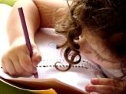  Literacy  Year 5 will be focusing on openings and ending in our fiction unit. Our model text will be “The Game”. Later on in the half term, Year 5 will turn their attention to non-fiction and the text be a discussion text. Our model text will be a discussion about whether children should be more responsible! I am sure the children will have great fun with this!  Reading  In our whole class reading sessions, we will be introducing our new class story “The Thief. The children are really engrossed in the story and we are looking forward to finding out what happens next! The class will also look at a selection of non-fiction and poetry texts. | Maths  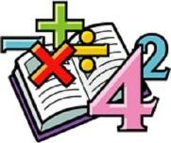  In maths, we will be continuing the great work done in year 4 on fractions. The children will be learning further knowledge of converting fractions and finding equivalents. We will be continuing to learn and practice our times table skills, to make sure we are fluently recalling them quickly and accurately. We will be completing arithmetic tests every week to make sure we are continuing to practise key skills and embed new ones. | Science  In science this half term we will be exploring a variety of different forces. We will learn about air resistance, water resistance and gravity. We will use our different enquiry skills to form questions about this unit and look to see which questions we can investigate and answer. The children will continue to develop their scientific enquiry skills to become scientists. | Computing  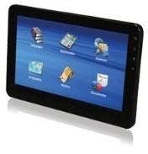  In computing, the children will be using coding programs such as scratch to make music. They will create this music in a loop and use their debugging skills to correct any errors that they might find within the music.
  Humanities  In history, the children will be learning all about the heroic age of antarctic. We will explore Antarctica, the timeline of events from this period as well as understanding why Captain Scott is still so famous today. | Our class books  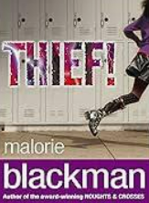 |  | 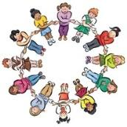  PSHE/RSE  This term in PSHE/RSE, we will be discussing matters relating to safety and the changing body. We will be discussing online safety, first aid as well as bodily changes as we grow up.  Through plenty of discussion, Year 5 will offer their opinions as well as listen and understand other’s views.
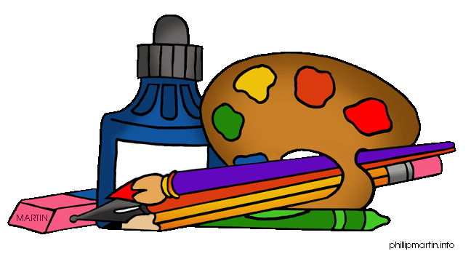  Art:  In art this half term, we will be exploring different fashion designers. We will then be creating our own designs in 2D and 3D, taking inspiration from the designers that we have explored. |   PE  We will also be learning a variety of different basketball skills.. As a class, we will be focusing on teamwork and fair play.  We will continue with our weekly swimming sessions on a Monday morning. |   French  In French, we will be brushing up on description and comparison. The children will use French adjectives to describe and make comparisons between planets in our solar system. |   RE  In RE, we will be looking at a key question.  Our key question this half term is:  What does it mean to be a Muslim in Britain today?

